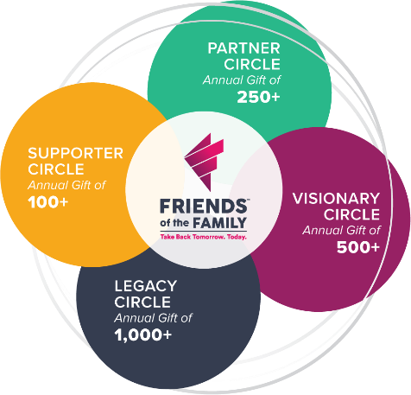

CIRCLE OF FRIENDS: ANNUAL CAMPAIGN

Our Mission: to provide safe shelter, confidential services, and housing assistance to individuals in crisis due to homelessness, domestic violence, sexual assault, and human trafficking.

Our Vision: through education and community engagement, we seek a future free of violence and homelessness.

Total Pledge $

Payment Options (Please choose one):

Payment of $_____________ Attached, or
__ I plan to make a single payment, send a reminder the month of ______________________
__ I plan to make 4 payments by June 30, send 4 reminders beginning ___________________
__ I plan to make monthly payments, send monthly reminder beginning __________________
__ I plan to pay by credit card
__ I plan to take from my payroll (staff only option)
Credit Card #_______________________________Type Exp. Date

Printed Donor Name ___________________________________________________________

Address: ____________________________________________________________________

Phone: ________________________ Email: _______________________________________

Donor Signature ______________Date ______

( ) Please contact me personally so I may complete my donation privately.
( ) Please contact me about a donation of stocks, vehicles, etc.
( ) I will be an Ambassador and invite my circle of influence to donate.
Comments ________________________________________________________________________________________________________________________________________________________________
Thank you for your financial investment in Friends of the Family. We promise to continue our effort to meet the needs of our community.

Make all checks payable to Friends of the Family

FRIENDS OF THE FAMILY
3835 w 9TH St, Waterloo, IA 50702
Phone 319-352-1108 Email erin@fofia.org

