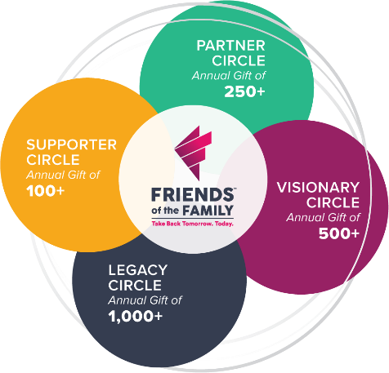

CIRCLE OF FRIENDS: ANNUAL CAMPAIGN

Our Mission: to provide safe shelter, confidential services, and housing assistance to individuals in crisis due to homelessness, domestic violence, sexual assault, and human trafficking.

Our Vision: everyone has a home.

Total Contribution $ ____

Donation Options (Please choose one):

Donation of $_________ Attached, or
__ I plan to make recurring monthly donations, starting ____________ ending ____________
__ I plan to make quarterly donations by June 30, send 4 reminders beginning ___________________
__ plan to make a single donation
__ I plan to pay by credit card /website
__ I plan to take from my payroll (staff only option)
Credit Card #_________________________Type Exp. Date cvv:

Printed Donor Name ________________________________________

Address: __________________________________________________

Phone: ________________ Email: ____________________________

Donor Signature _______________ Date __________

( ) Please contact me personally so I may complete my donation privately.
( ) Please contact me about a donation of stocks, vehicles, etc.
( ) I will be an Ambassador and invite my circle of influence to donate.
Comments ________________________________________________________________________________________________________________________________________________________________
Thank you for your financial investment in Friends of the Family. We promise to continue our effort to meet the needs of our community.

Make all checks payable to Friends of the Family

FRIENDS OF THE FAMILY
1009 Peoples Square, Waterloo, IA 50702
Phone 319-576-2240 Email erin@fofia.org

