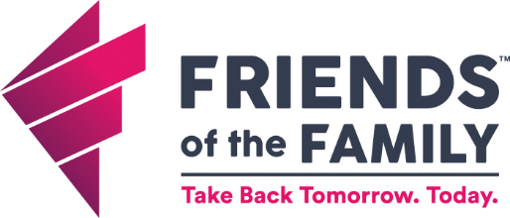
Employee Job Description
Housing Support Specialist (Safely Home)
Program: Housing Services
Status: Full-Time, Non-exempt
Reports to: Housing Services Director
Direct Reports: None
Job Summary:
Provide case management services to victims in our Safely Home Project in both transitional housing and rapid rehousing settings. Collaborate with service providers to assure that victims receive support and safety.
What you will do:
- Provide direct case management/life skills/housing services support and counseling to program participants in the identified service area.
- Develop and maintain local partnerships with landlords, housing programs and community partners to assist in quick access to safe affordable housing.
- Apply knowledge of landlord/tenant rights and responsibilities to educate participants of their rights and responsibilities.
- Provide advocacy, crisis counseling, and access to services to victims on our crisis line.
- Support the efforts of the crisis services team in navigating safe shelter and housing options for survivors of violence.
- Comply with data tracking and documentation requirements
- Represent FOF at community and program development meetings as assigned.

How You Will Succeed:
- People First- Everyone matters and you regard people's well-being and success as a priority.
- Do the Right Thing- Act with integrity and doing what is best for the greater or common good. It means making decisions that are not based on your own personal needs, that do not expand your popularity, or enforce your personal beliefs.
- Own Your Role- Be highly accountable and do the job you were hired for. If you're owning yours, you aren't worried about, preoccupied with, or diluting your attention to anyone else's. Owning your role means focusing on only what you can control and letting your teammates do the same.
- Embrace and Drive Change- We learn not to fear change but instead embrace it enthusiastically. It is even more important that we encourage and drive it. That keeps us in a healthy state of change readiness. Change is based around humbleness and an understanding that we can always grow and get better.
- Diversity, Equity, and Inclusion-Believe that diversity makes us all better and enjoy working with people of different backgrounds. Work to make all your teammates feel welcome and understand that we must provide equitable opportunities for all.
- Teamwork and Community Engagement- Rely on our work with others internally and externally to successfully meet the vision and mission of FOF. We can accomplish great things when we work collectively. Cheer for your teammates to succeed and uplift when things are tough. Don’t let others down.
- Understand, align with and practice under the following philosophies/models: Housing First Model, Trauma-Informed Care, Client-Centered Approach, Harm Reduction, and Low-Barrier Shelter.
- Believe in our 10-year vision to end homelessness and violence.
- Believe in our mission: To provide safe shelter, confidential services, and housing assistance to individuals in crisis due to homelessness, domestic violence, sexual assault, and human trafficking.
- Understand the 6 components of the Entrepreneurial Operating System (EOS).

Job Qualifications and Competencies
- Must demonstrate ability to organize, prioritize and plan work to meet deadlines.
- Ensure confidentiality is in place for all people FOF serves.
- Bachelor Degree in social work, psychology, related field OR combination of equivalent education and experience.
- Previous experience in the following preferred: victim services, crisis intervention, housing programming, and/or case management.
- Ability to travel throughout the FOF service area to provide in-person advocacy services and to other locations within the state as necessary for training purposes.
- Ability to pass state, federal, and child abuse background checks.

Employee Signature:
I have reviewed and understand all the information contained in this job description and I am physically able to perform the duties.
I acknowledge that the contents of this job description are not to be construed, in part or in whole, as a guarantee of employment. I understand that Iowa is an at-will employer, and therefore, my employment is at the will of myself, the employee, and Friends of the Family.

___________________________________________________________ ______________________
Signature Date

